Vehicle of Interest – Desktop

VOI Implementation Screenshots

Stanley De Jesus

SWEN661 – User Interface Implementation

January 24, 2022

1. VOI Main Window when the application is loaded.

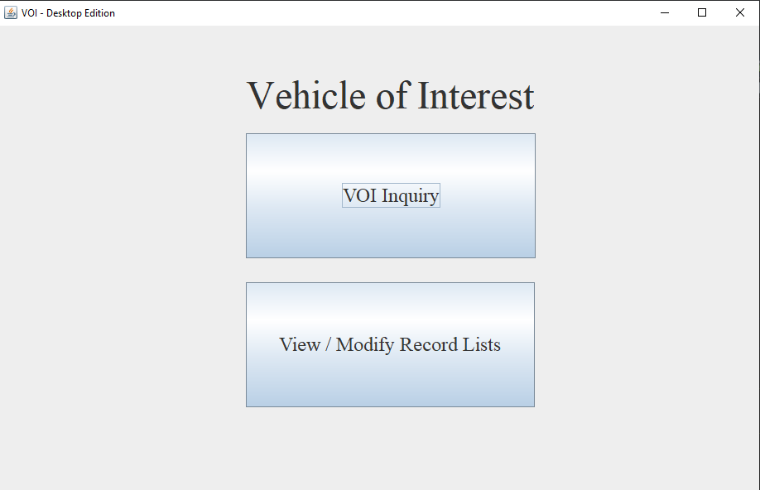

Figure 1

1. The user clicks the VOI Inquiry. View Vehicles of Interest Screen Opens. The application populates the table with Vehicles of Interest data

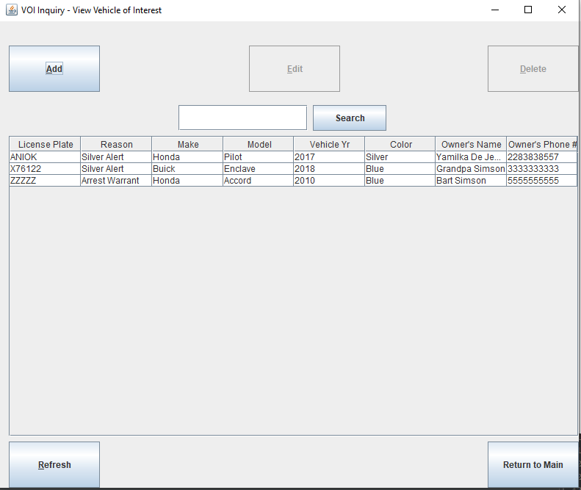

Figure 2

1. Vehicles of Interest - Add Window.

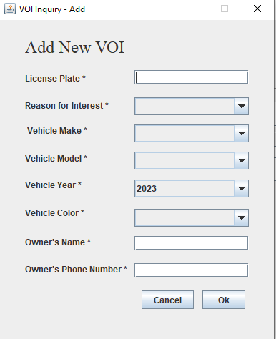

Figure 3

1. Vehicles of Interest Add Screen if any text fields are empty – Error message is at the bottom.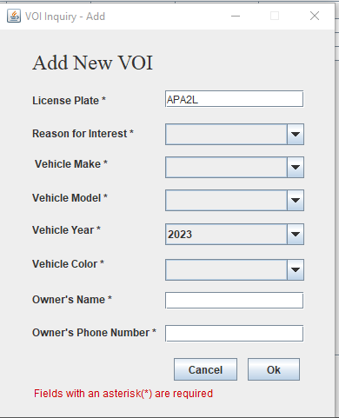

Figure 4

1. VOI screen – if the owner’s phone number is not empty and doesn’t contain ten digits, an error stating “owner phoner number must have ten digits only” is shown at the bottom of the screen.

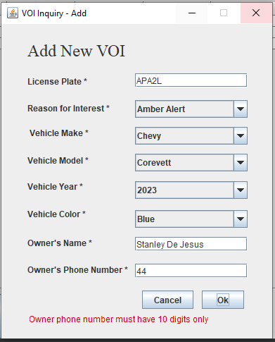

Figure 5

1. If filled in and added to the database, it will close the VOI add window and return the user to the view VOI window. When the user clicks the refresh button, it will reload the database and show the new row entry.

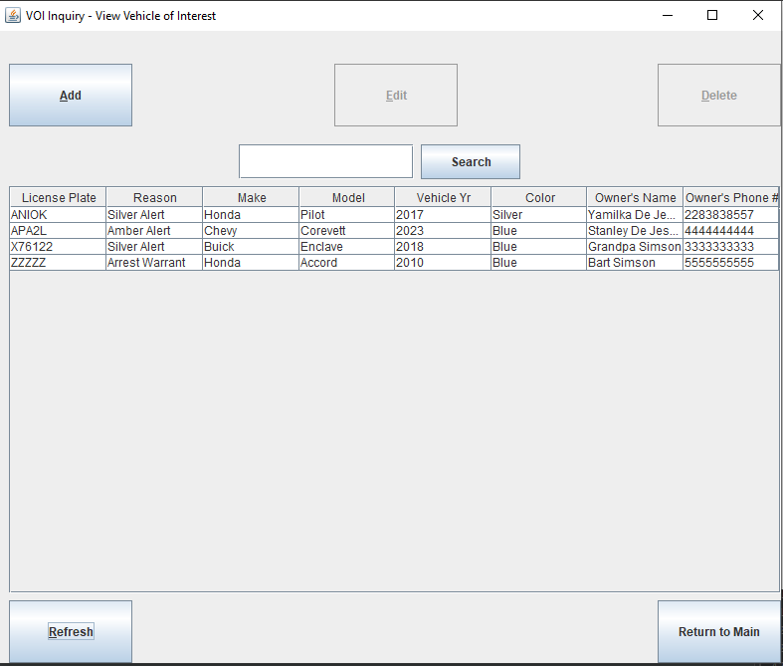

Figure 6

1. The below screenshot displays that The edit and delete buttons are active when the user selects a row.

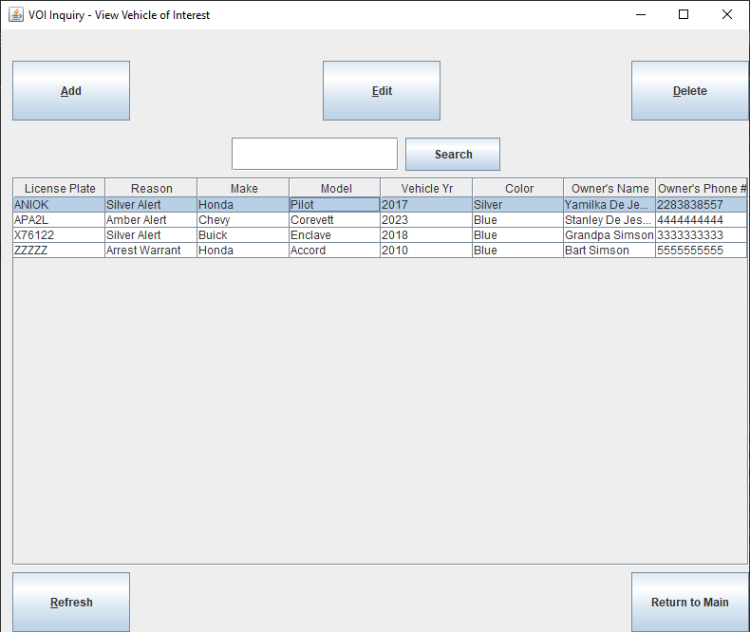

Figure 7

1. The edit button is clicked, and the VOI edit window.

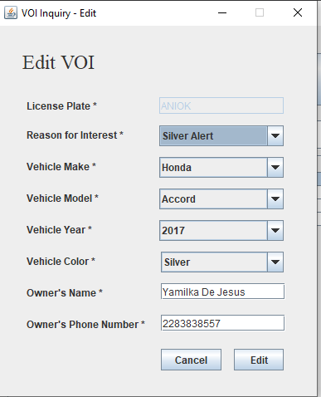

Figure 8

1. Once changes are made, the edit button is clicked, the database is updated, and the edit screen will be closed. The view VOI screen below is displayed after the refresh button is pressed. When the table entry is selected, it enables the edit and delete buttons.

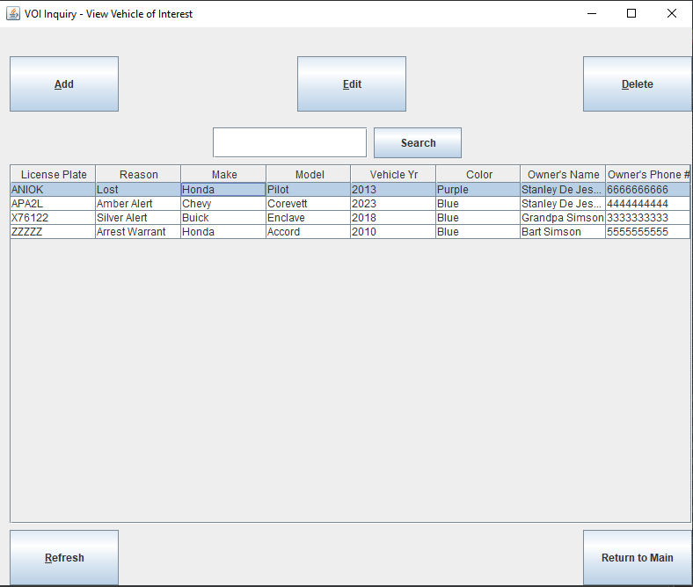

Figure 9

1. The delete button is shown once the delete button is clicked with the selected rows information.

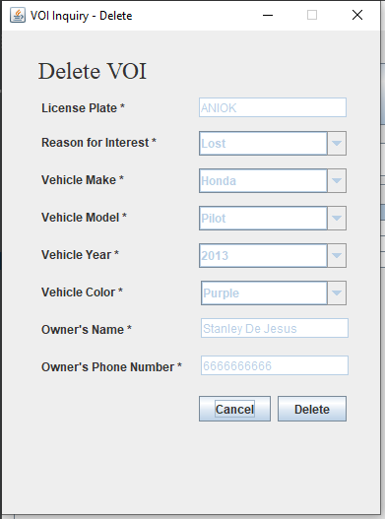

Figure 10

1. This screenshot illustrates that once the delete entry is performed, it closes the delete screen, and the view vehicle of interest screen is shown once the user clicks the refresh button.

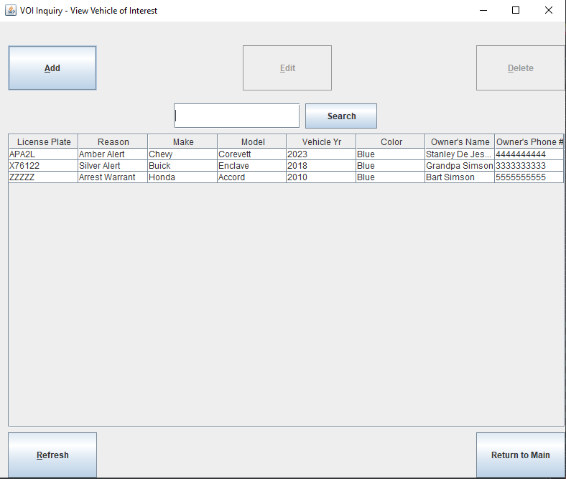

Figure 11

1. This screen displays the user inserting a license plate that exists in the database.

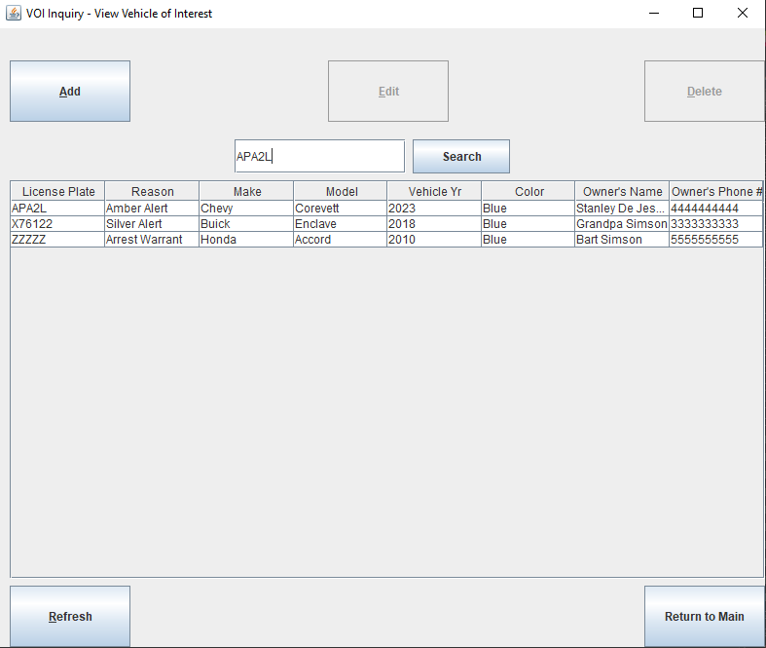

Figure 12

1. The below shows the result once the user clicks the search button.

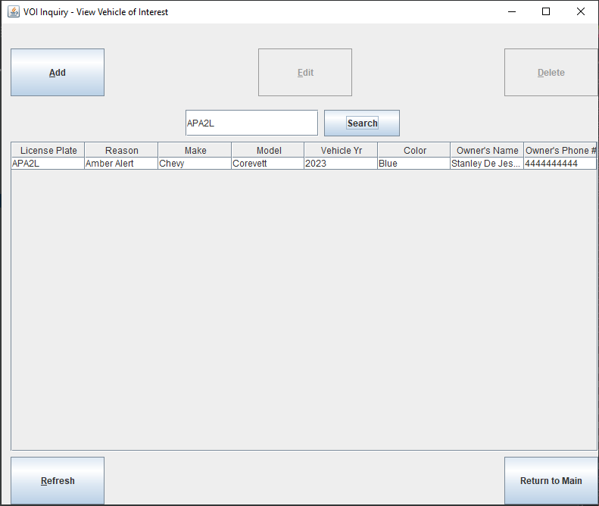

Figure 13

1. The user inserts a license plate that doesn’t exist.

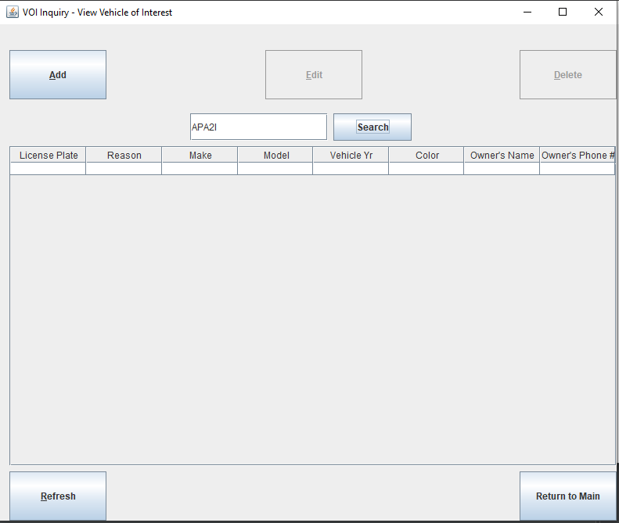

Figure 14

1. The main screen



Figure 15

1. When the user clicks the “View / Modify Record Lists” button, the select attribute table screen is shown.

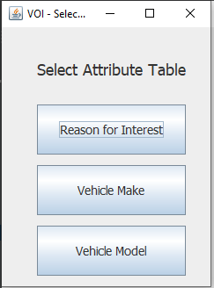

Figure 16

1. The user clicks on the Reason for Interest button.

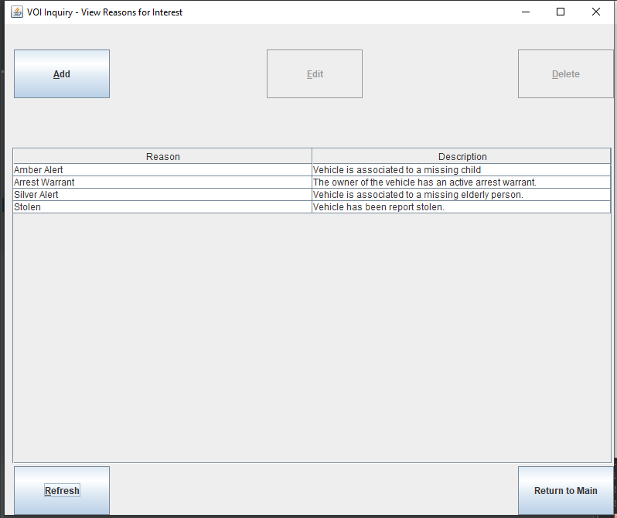

Figure 17

1. The user clicks the add button.

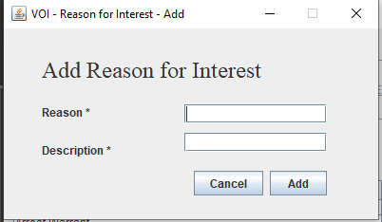

Figure 18

1. The user does not fill in all the required fields and clicks on the add button. The window shows an error “Fields with an asterisk (\*) are required” at the bottom.

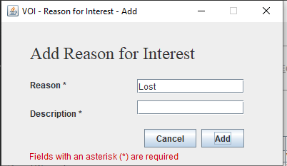

Figure 19

1. The user fills in all the required information before clicking the add button.

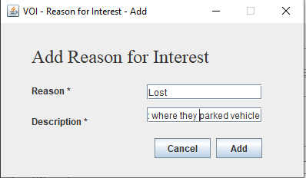

Figure 20

1. The entry is inserted into the database, and the add screen is closed.

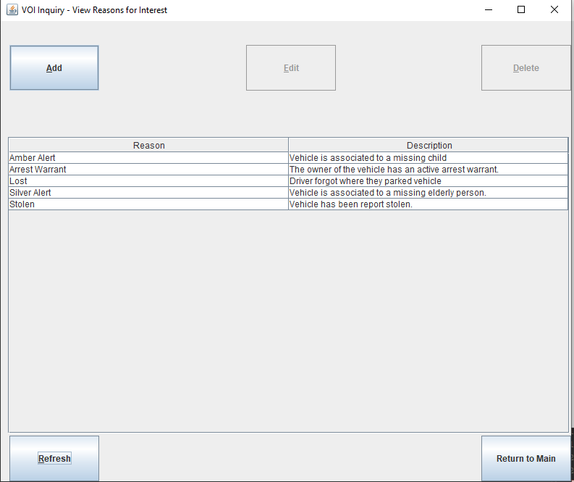

Figure 21

1. A row is selected on the table, and then the edit and delete buttons are active.

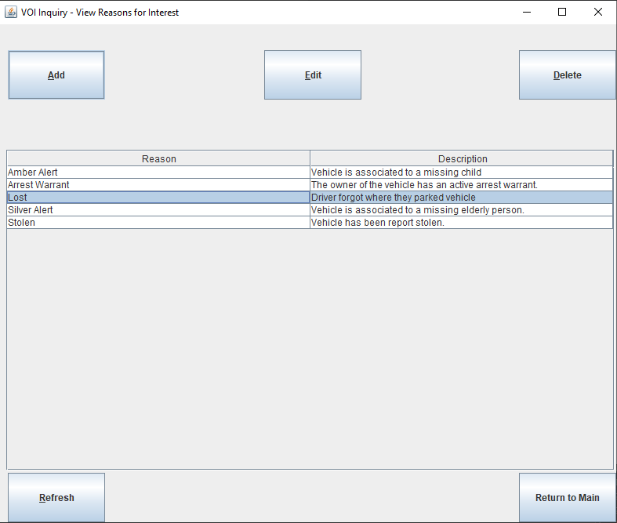

Figure 22

1. The edit button is clicked.

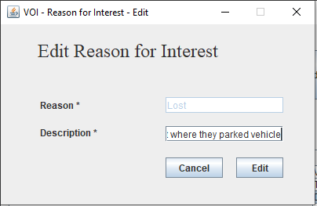

Figure 23

1. The description is removed, and the text box is empty, showing an error at the bottom of the screen.

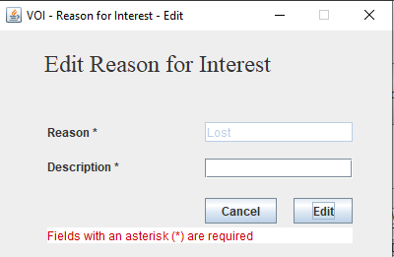

Figure 24

1. The edit screen has its description changed.

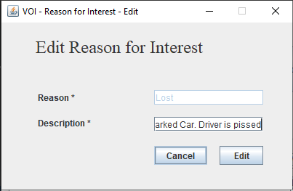

Figure 25

1. The change is made to the database, and the edit screen is closed. Then, the user clicks on the refresh button and selects the table entry.

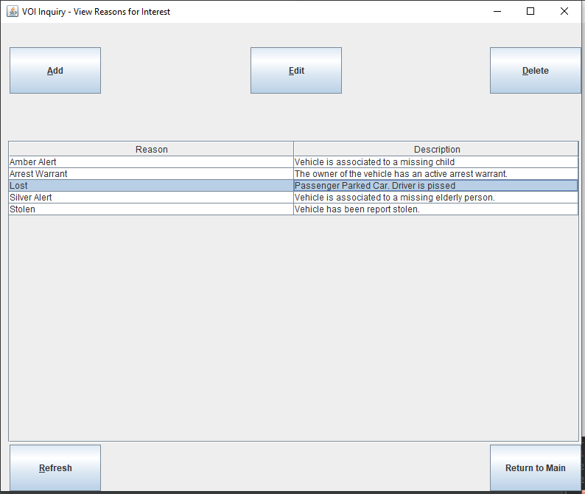

Figure 26

1. The delete button is clicked, and the below screen is displayed with the text fields disabled.

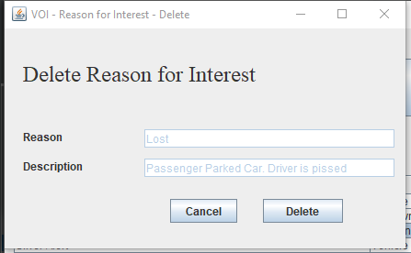

Figure 27

1. The user clicks the delete button, the delete operation is executed, and the delete screen is closed.

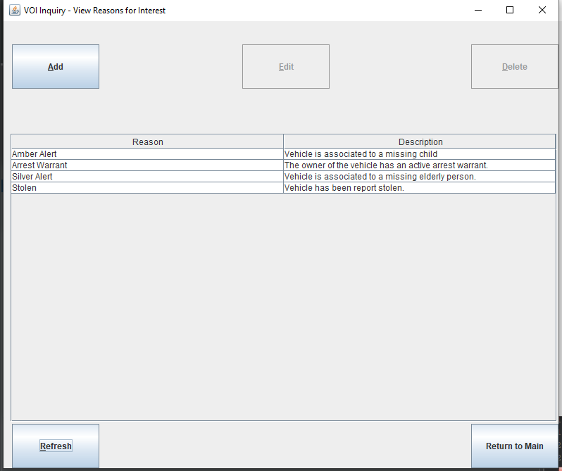

Figure 28

1. The Select Attribute table before clicking on the vehicle make jbutton.

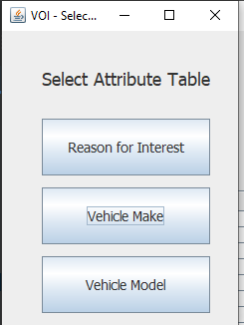

Figure 29

1. The vehicle make screen is opened.

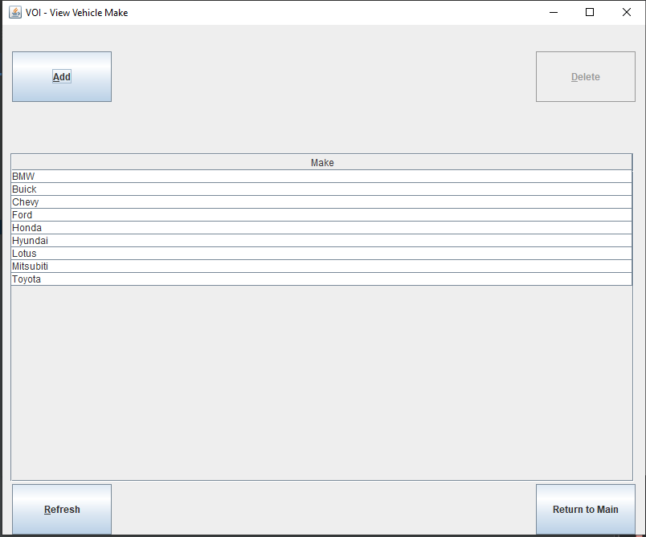

Figure 30

1. The add button is clicked.

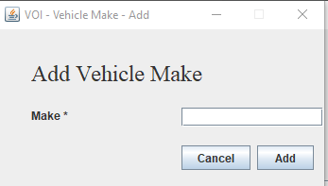

Figure 31

1. The user leaves the text field empty when the add button is clicked. An error is displayed at the button informing the user that all required fields must be filled.

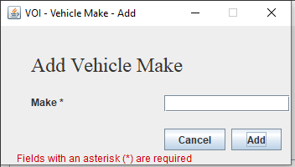

Figure 32

1. The user inserts a make before clicking the okay button.

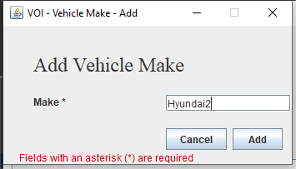

Figure 33

1. The delete operation is complete, and the add window is closed. The user then clicks on the row entry.

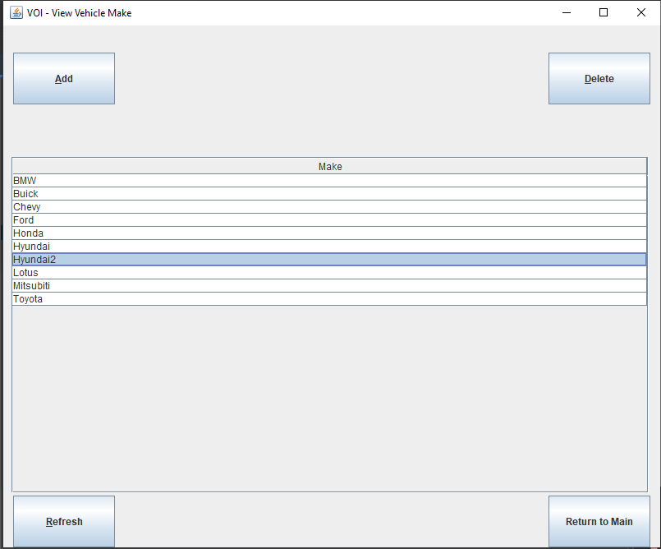

Figure 34

1. The delete button is clicked, and the application opens a new window with the selected rows information. The text field is disabled.

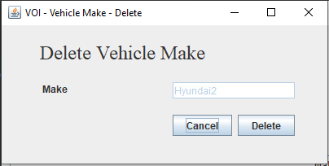

Figure 35

1. The user clicks the delete button, the database completes the change, and the delete screen is closed.

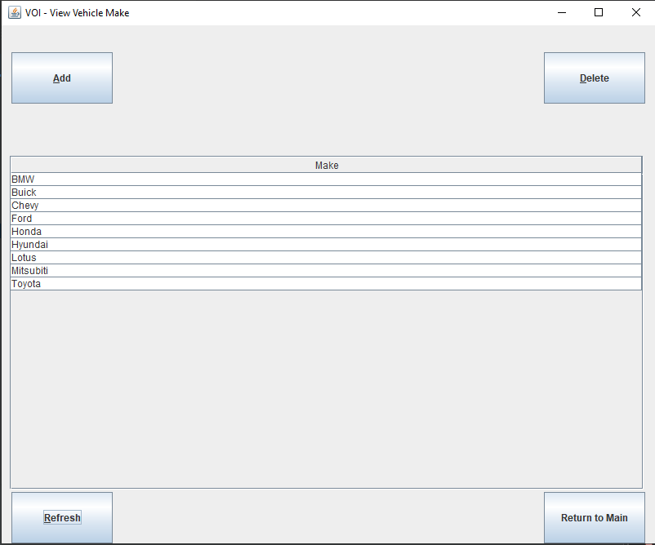

Figure 36

1. The select attribute table screen before the vehicle model button is pressed.

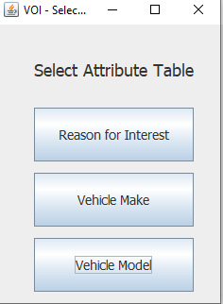

Figure 37

1. The view reasons for interest screen is displayed

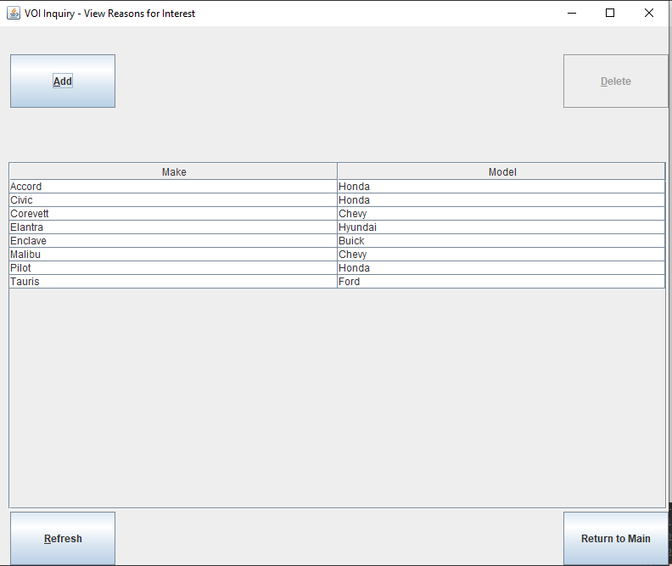

Figure 38

1. The Vehicle model add button is clicked.

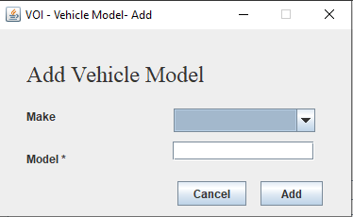

Figure 39

1. The user clicks the add button while leaving the required fields empty. An error is shown in the bottom.

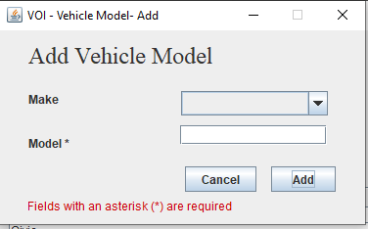

Figure 40

1. The user inserts one field but leaves the other empty.

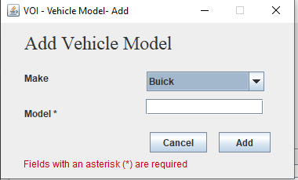

Figure 41

1. This screen shows what the user inserts before clicking the add button.

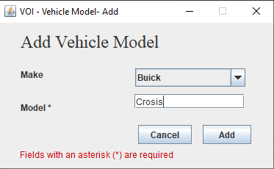

Figure 42

1. The database adds the entry and closes the add window. The user then clicks on the inserted row once it becomes available after the refresh is clicked.

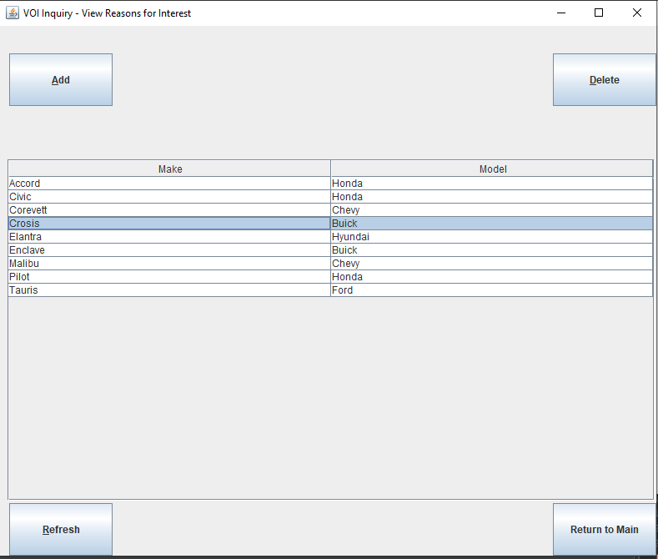

Figure 43

1. The user clicks the delete button, opens the delete window, and populates the row information into the disabled combo box and textfield.

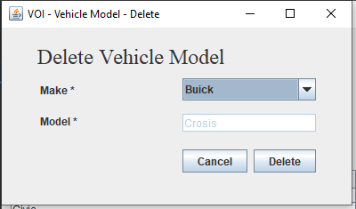

Figure 44

1. The user clicks the delete button, the database removes the row entry and closes the delete window.

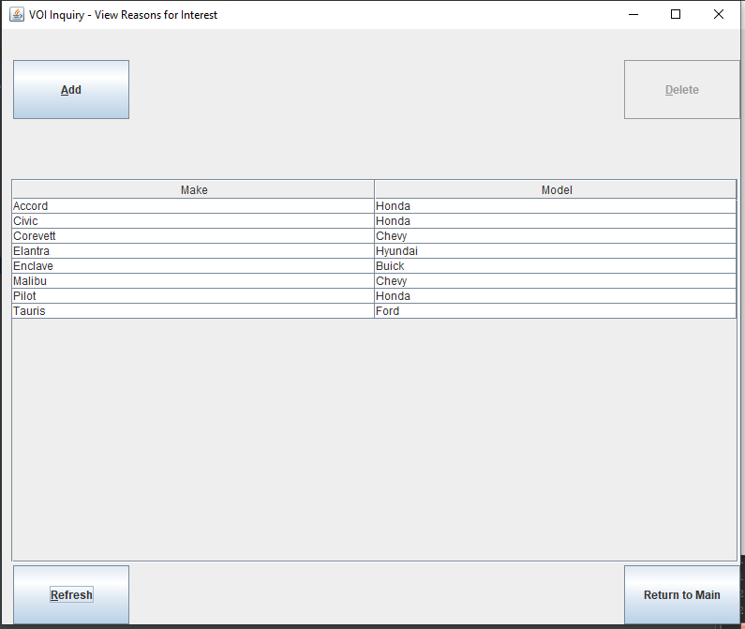

Figure 45